Loadtest report

Table of Contents

1. Test objectives 3

2. General test conditions 3

3. Tests performed 3

3.1 Network test 3

3.2 Load test 3

4. Idle metrics 4

5. Network test metrics / results 6

6. ECS container load test metrics / results 9

7. Conclusion 11

# 1. Test objectives

We need to find out if the web site meets the performance requirements as specified below.

The site needs to be able to handle 1000 unique visitors per day providing the industry standard level of service in terms of response time and error rate. Average response time should be less than 5 seconds and error rate should be less than 1%.

We that average number of simultaneous users on site will be about 100, during the peak hours it will grow to 250. We need to check that the site can handle this load.

We expect most users to only upload files, but our infrastructure scales to 5 possible Fargate instances in case multiple users choose to convert large video files.

# 2. General test conditions

The following test conditions are ideal for simulating the actual site usage:

between 15 and 20 page requests each user session;

Average user time on site: 10 minutes;

a) browse site content and initiate uploads (75%); b) convert video files (25%).

# 3. Tests performed

The following two tests have been designed and executed.

Network test:

We executed a network test to check our network / load balancer stability. We used Locust and made a test of three and a half thousand users, where every second ten would join.

In this ECS container load test, we evaluated the functioning of our web application by converting movies. We gave it 2001's Shrek, in 720p, 1,03gb in size.

# 3.1 Network test

**Test duration:** 5+ minutes;  
**Load type:** ramp-up from 0 to 3250 users with step 10, every 1 second.

# 3.2 Load test

**Test duration:** 1+ hour;  
**Load type:** ramp-up cpu, ram, network and disk usage.

# 4. Idle metrics

These are our webapp's idle metrics of the last 24h. Dashboards speak for themselves. (Time scale may vary depending on the readability of the graph)

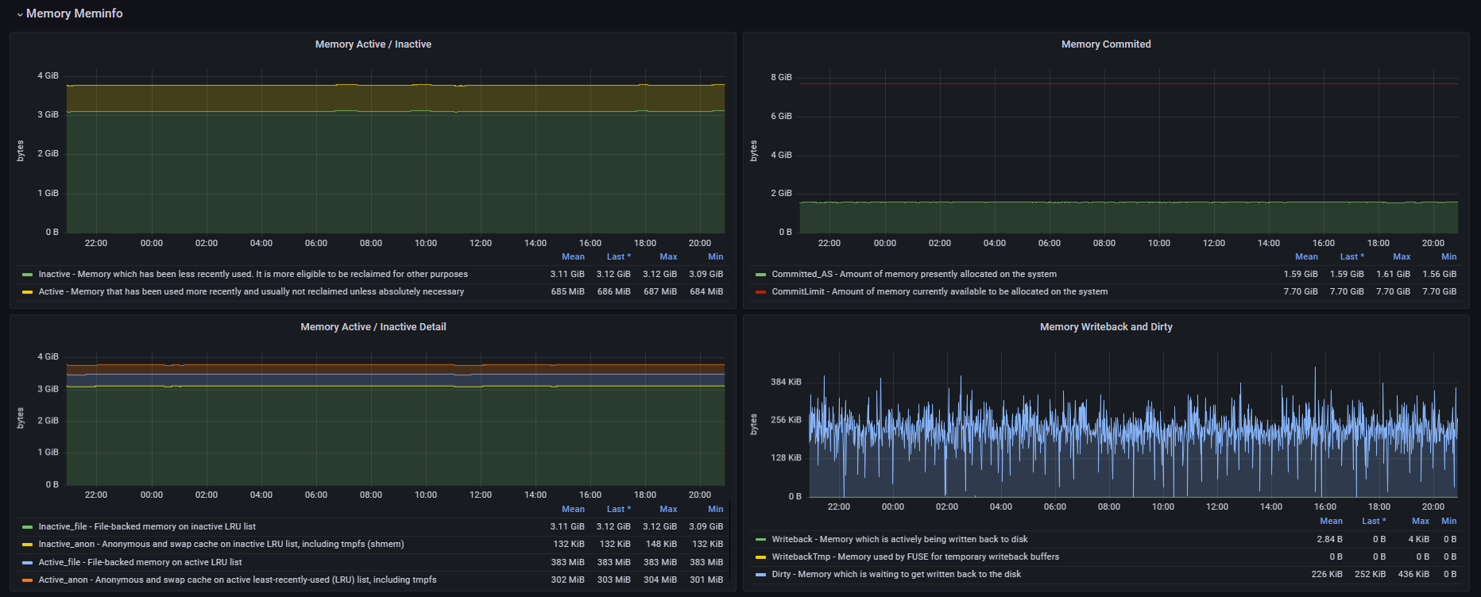

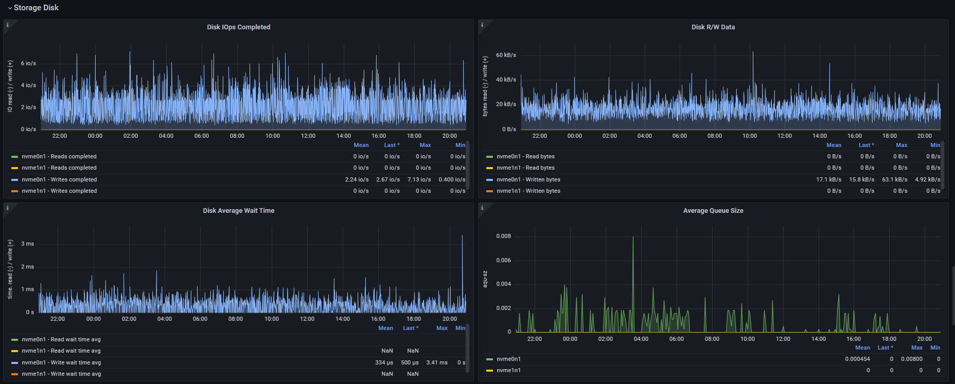

# 5. Network test metrics / results

These metrics represent the metrics under the load of the Locus test. (Time scale may differ according to viewability of graph)

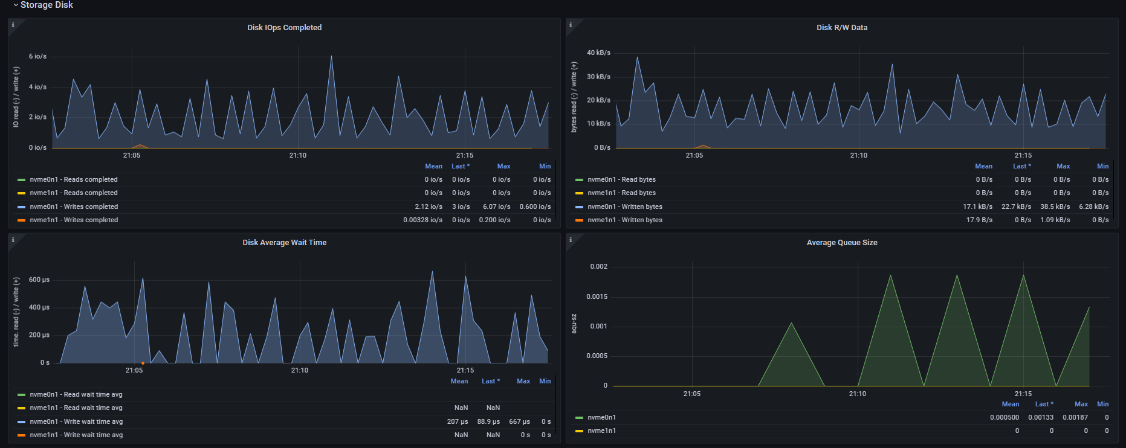

These are the results of the locust test.

# 6. ECS container load test metrics / results

These metrics represent the metrics under the load of the video conversion test. (Time scale may differ according to viewability of graph)

Autoscaling working

In the past few days, running the infrastructure to generate logs has dramatically raised our expenses.

# 7. Conclusion

The website may exhibit slowdowns characterized by poor response times under excessive user connection loads. The required level of service is provided when the load is average or less than average. (Approximately 10ms response times) This is because Locust crashed before our website due to the excessive load we attempted to place on it.

When a website is under load because a video is being converted, the application automatically scales up and correctly creates a new task. This ensures that the application continues to operate efficiently for all users. If six conversions occur concurrently, the website will experience slowdowns.